**I - Explore**

**PROJECT PLAN**

**Team members:**

**1. Vishnu Praveen Gude**

**2. Ravi sankar Are**

**3. Venkata naveen Pandala**

**4. Ayyappakumar Neerukonda**

**Introduction:**

In now a days many people want to study their higher education in United States. Let us take Master’s , Many of the students from different countries will come every year to full fill their dreams with all qualifications, But without the basic knowledge about this country like weather conditions, Housing, rules and regulations etc.., because US is one of the largest nation with 50 states. So lack of the knowledge about the university surroundings and all will lead to students to some initial fear about their future or transfer to some other university. So our main motivation in this project is to design a mobile web app for our university to know all about education standards and Surrounding areas.

**Project goal:**

Project overall goal is simple and clear, like to explore the new upcoming students in different aspects of education( like choosing a department, course curriculum etc..,), and surroundings( like weather conditions throughout the year, housing, locating stores). Even though many websites are providing this information, we want to gather all the information and make it available into one website to have a better user interface. We will try to implement all the things in diagrammatic manner to understand easily for users.

**Specific objectives:**

**Problem statement:**

Many of the upcoming students to university did not know the basic requirements to get an admission in the university, education here, weather conditions, about on campus jobs, department professors etc.., so here are some objectives to overcome all this…,

1. To know the real Scores need to enter into university for different departments.
2. To find the information after student came here like on campus jobs etc…,
3. To find the different countries students ratio.
4. Initial accommodation for students.
5. Providing different links to learn about the things In surroundings.
6. Professor’s information and their research interest.
7. Provide on campus jobs information.
8. Entertainment angle.
9. * virtual tour of university surroundings and nearby areas using google API’s.

**Significance:**

The importance of this project is to explore many students from many countries to grasp all the information about the university education and providing real experience even though he/she is in home country. We will provide a service named virtual tour of the university by using google services and near by walmarts etc..,

**Project background and related work:**

Even though many websites are providing the information, we will collect all the genuine information and make it as a diagrammatic view for the users to understand it easily, even though they have less knowledge to grasp. Some of the websites, we want to gather information are……..,

1. [www.umkc.edu](http://www.umkc.edu)
2. [www.usnews.com](http://www.usnews.com)
3. [www.msinus.com](http://www.msinus.com)
4. <http://www.50states.com/college/>
5. [www.studentsreview.com](http://www.studentsreview.com)

We will also contact departments to have genuine information about the admission processing and all.

Similarities with others work:

1. Providing the scores required to meet all the requirements for an university.
2. Providing details in university website.
3. Providing weather conditions.
4. Google maps.

Differences :

1. We will collect each student information and generate a reference I.D to them.
2. Providing diagrammatic views for each service to have a better understanding.
3. Providing genuine information by taking it from particular departments.
4. Implementing Google maps service to have a virtual tour of the university.
5. Finding housing, stores like walmart, costco near by university etc..,
6. To find Entertainment spots.

**Proposed system:**

**Functional specifications:**

1. System requirements:

User has to enter the data in to the home screen, next it will process to further page and confirm it with reference I.D.

Next it will review the student profile and decide the admission chances.

1. Interface requirements:

User has to give the source and destination address to have google API views.

Virtual tour of university will be provided by clicking the virtual tour button.

1. **Security reqirements:**

Members of the administration are only able to change or edit the data.

Users are able to add members but not deletion of members

Members of the administration can be able to maintain a database of students records those are private.

**Workflow analysis:**

The main aim of this project is to collect the required information from department to produce admission service.

To collect information from different websites to produce housing service.

To collect information from google maps to produce virtual tour and API views.

**Technology requirements : php, netbaens.**

**Framework specification:**

**Assumptions:**

User has known his/her scores to enter into the website, which we created.

**System architecture diagram:**

**Front end:**



**Back end:**



**System specifications:**

**Existing services:**

University admission, weather service on day by day basis, google maps, university website, department information.

**New services to built :**

Admission criteria based on scores by department, google helicopter views, university virtual tour, surrounding areas linkup, department detail information.

**Service specifications:**

1. **Admission criteria:**

This service involves the user to create an user i.d and enter all the detailslike scores and the output would be wheather he/she will get admit or not by using the information collected from department. Importance of this service is mainly collecting the genuine information from department and changing it accordingly to every semester.

1. **Weather display service:**

This service involves the user to display the weather along the semester, which he/she wants to be join. The main importance of this application is to collect the weather information from accu.weather site and draw it accordingly year wise and display it. The main difficulty is that we don’t when weather will changes around the year.

1. **Google api views:**

This service will create the user to view different places among the city surroundings to have a realistic view of the university before coming here. The main conflict here is the google satellite maps are somewhat outdated.

1. **Departmental information:**

The most importance of this service is, we want to collect some secret data from department to have access for users only who got positive response from admission criteria service and information of professors , their profile and their research interests and classes etc..,

1. **FAQ’s:**

This is one of the extra feature we want to add to this project, which it is collect some questions from users and then post answers to website.

**Class and sequence diagrams for services:**

Admission criteria:



Google API views service:





Weather API service:





Virtual tour view:



**Plan by service(Using Scrumdo):**

**ITERATION PLANNING:**

First I added all the team members to our project team.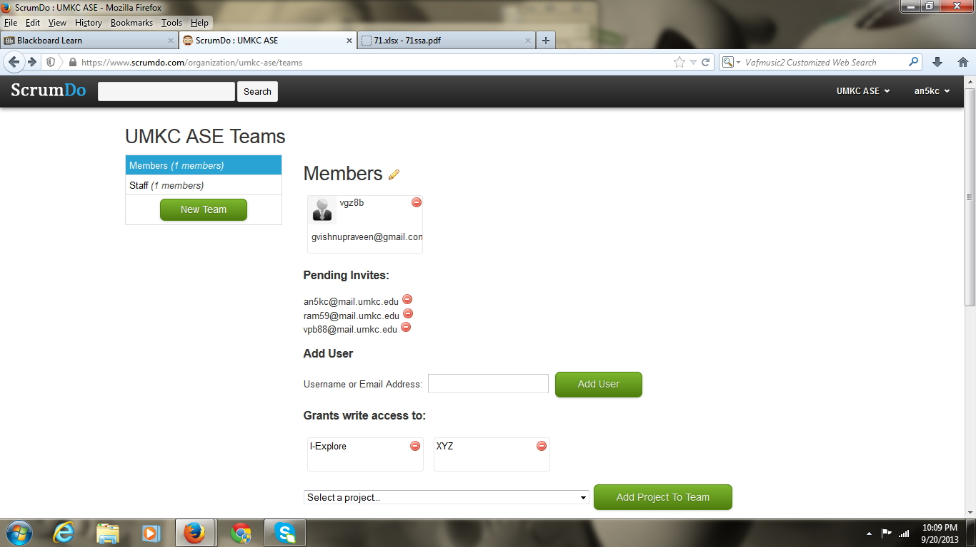

**Creation of first iteration:**

We named the first iteration as creating login page. In this iteration we create web page using PHP, in this those who are interested to apply to UMKC has to register by providing required information for the admission like GRE score, English Proficiency Test Score( For International Students) , Work Experience ext. Then they are provided username, password and their information is saved in the server. And mail will be given to them whether they can get admission into their required field it or not. After completion of this iteration we do testing also.

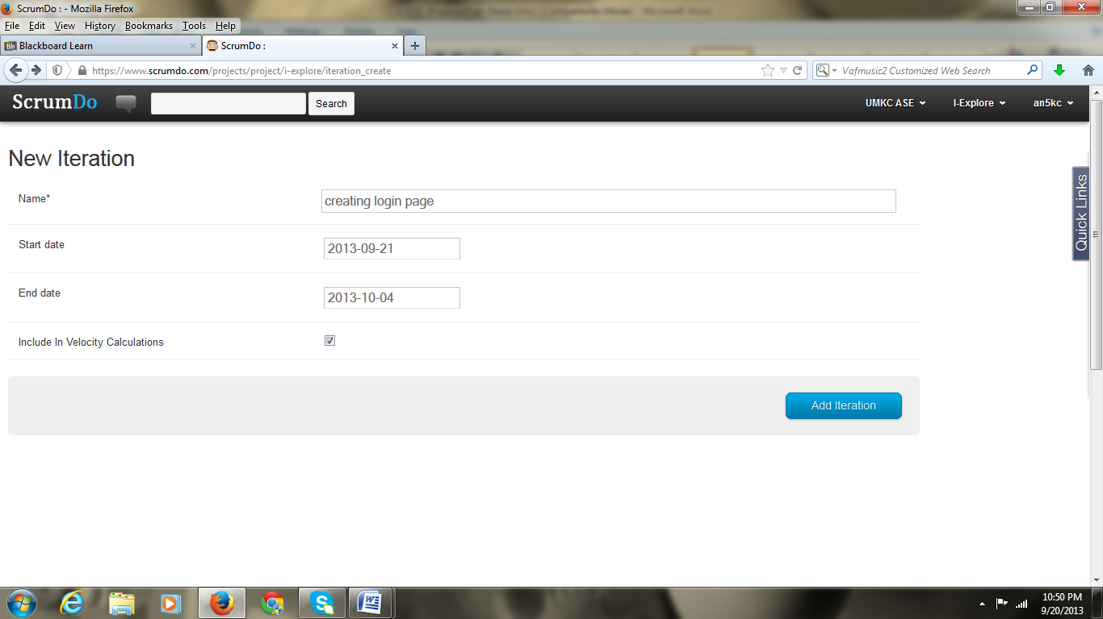

And story will be created.

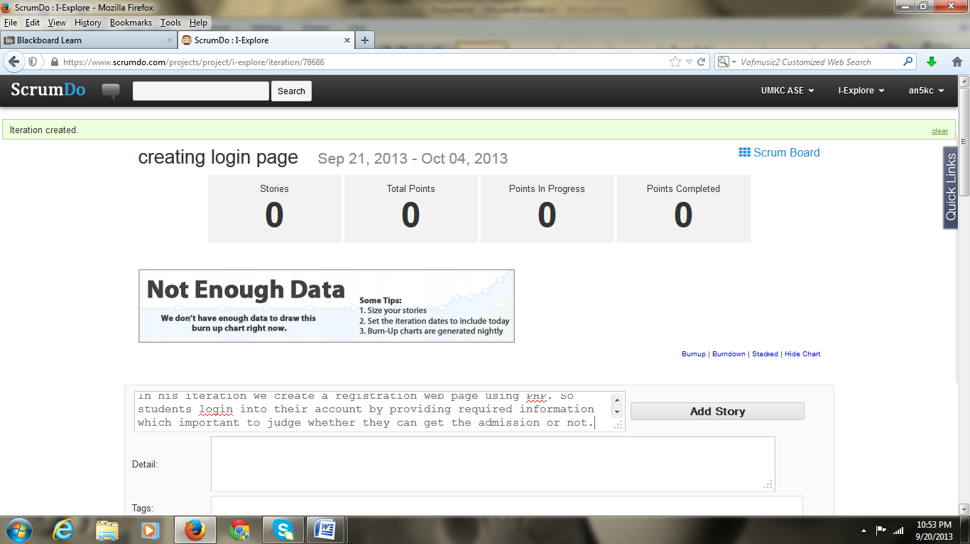

**Creating the second iteration:**

In this iteration we will provide very useful information to the users. The information is regarding Housing around the university, shopping , entertainment and transportation ext. For providing these services we use Google services. After completion of this iteration we do testing also.

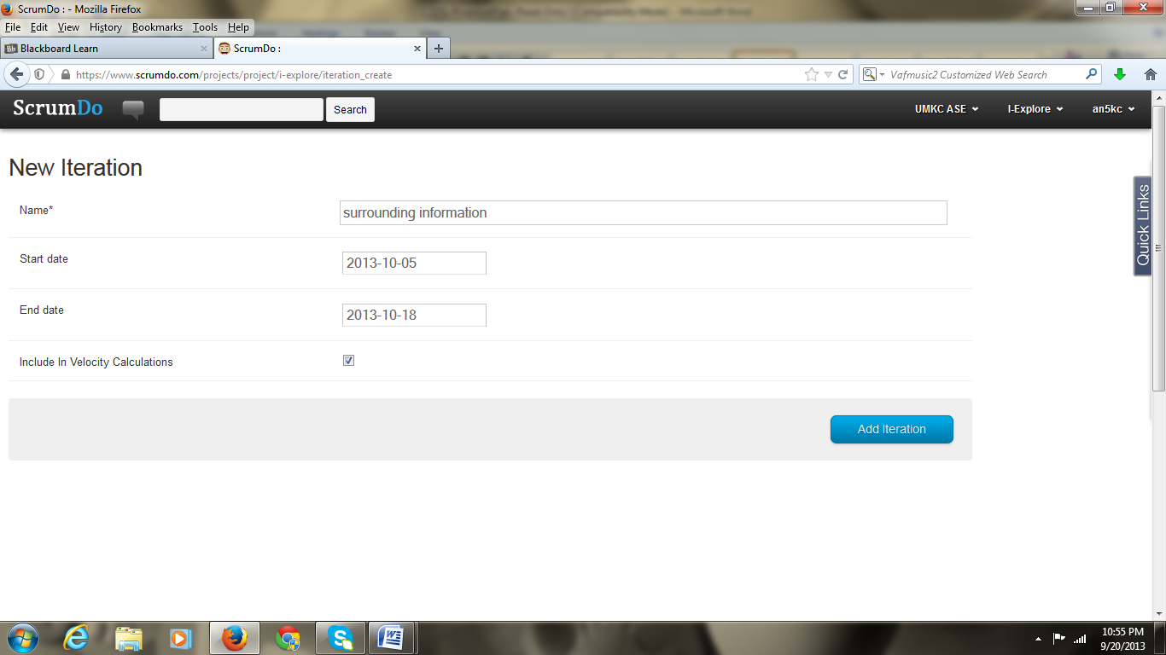

Story is created for second iteration

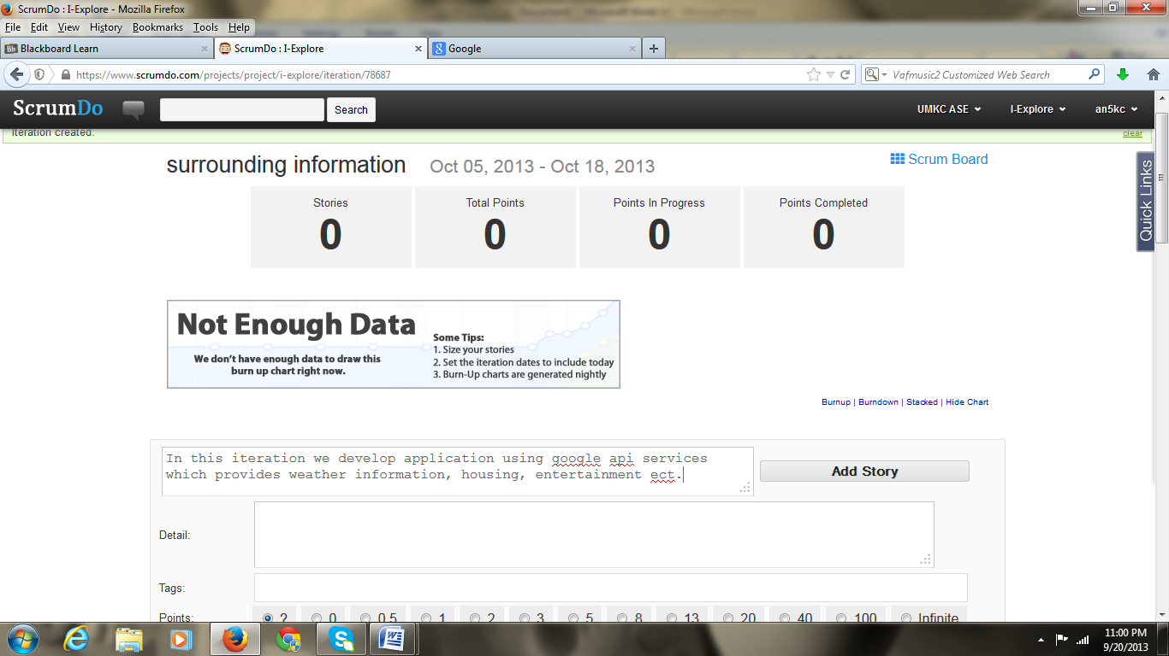

Creation of Third iteration:

In this iteration we provide weather information about Kansas city and it’s surroundings. For this we will use weather services. After completion of this iteration we do testing also. For this iteration story also be created.

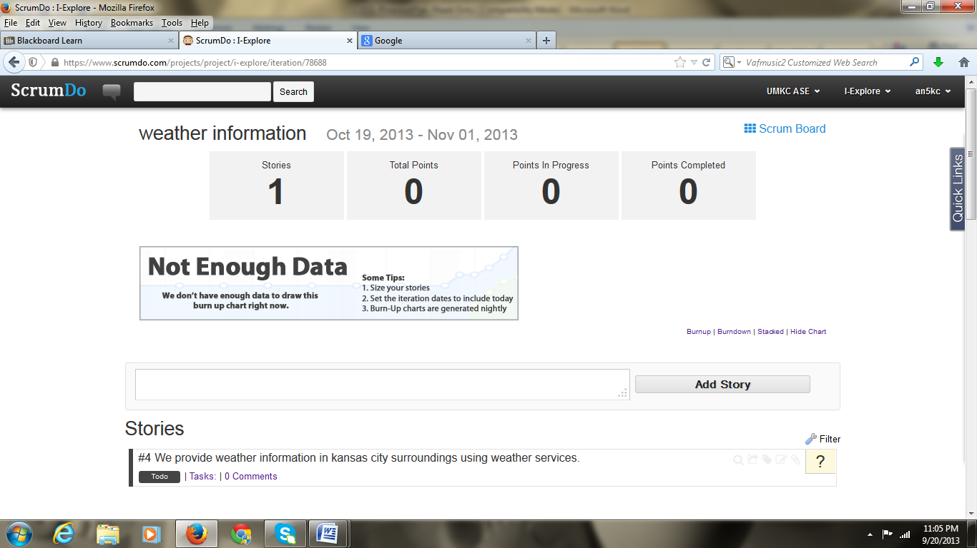

**Creation of fourth iteration:**

In this iteration we provide some useful information to users. It can be helpful for them in arranging tours. For this we use Google Maps Services. Story also be created for this Iteration

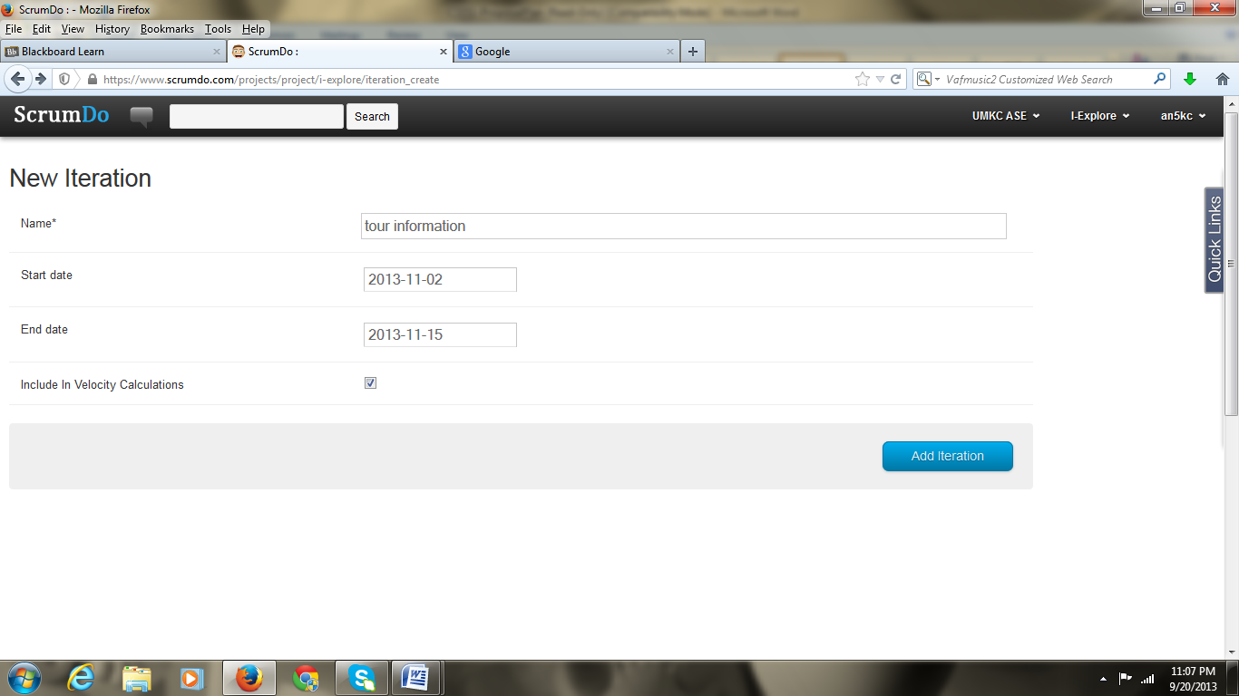

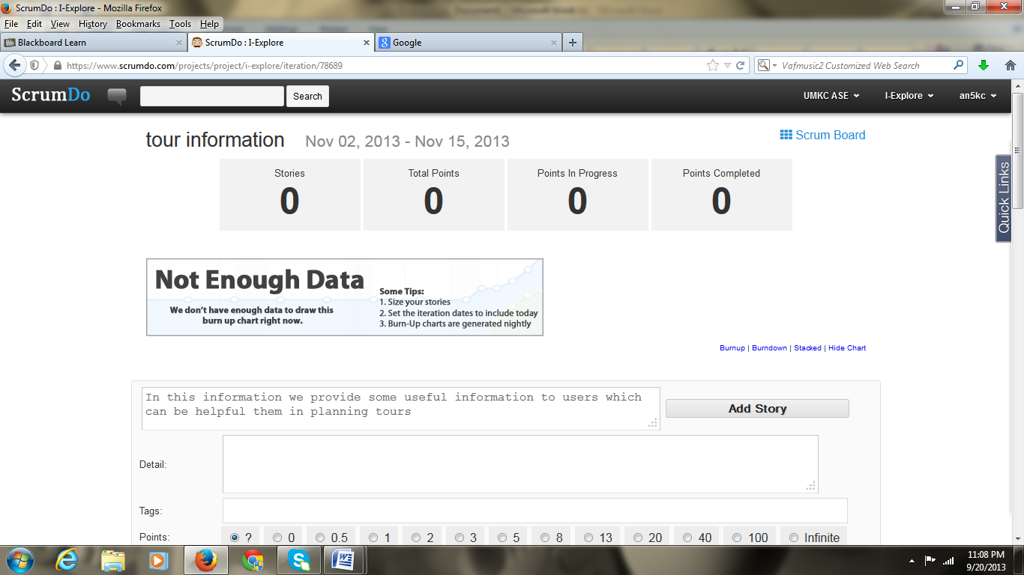

**Risk management:**

Risk management is from two factors:

1. Fake users: When fake users want to see the details of some private information of users to know the user profile, its problem.
2. Outdated information: Maintaince of the site is another risk factor. Administrator has to keep te site up-to-date.